# **Name: Abdurrahman Qureshi**

# **Roll No: 210451**

Practical No: 14

**1) Write a Program to show the following output.**

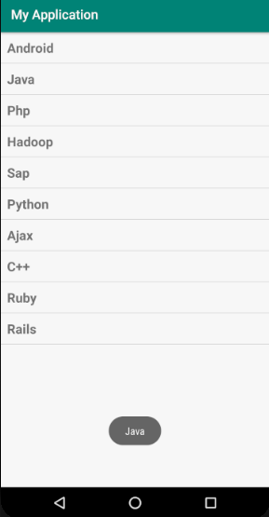

**XML Code:**

**activity_main.xml:**

<?xml version="1.0" encoding="utf-8"?>  
<LinearLayout xmlns:android="http://schemas.android.com/apk/res/android"  
 xmlns:app="http://schemas.android.com/apk/res-auto"  
 xmlns:tools="http://schemas.android.com/tools"  
 android:layout_width="match_parent"  
 android:layout_height="match_parent"  
 android:orientation="vertical"  
 android:padding="10dp"  
 tools:context=".MainActivity">  
  
 <ListView  
 android:layout_width="match_parent"  
 android:layout_height="wrap_content"  
 android:id="@+id/lang_list">  
 </ListView>  
  
</LinearLayout>

**listview_text.xml:**

<TextView  
 xmlns:android="http://schemas.android.com/apk/res/android"  
 android:layout_width="match_parent"  
 android:layout_height="match_parent"  
 android:id="@+id/label"  
 android:textSize="20sp"  
 android:padding="10dp"  
 android:textStyle="bold">  
</TextView>

**Java Code:**

package com.example.madprac14;  
  
import androidx.appcompat.app.AppCompatActivity;  
  
import android.os.Bundle;  
import android.view.View;  
import android.widget.AdapterView;  
import android.widget.ArrayAdapter;  
import android.widget.ListView;  
import android.widget.TextView;  
import android.widget.Toast;  
  
public class MainActivity extends AppCompatActivity {  
  
 String[] programmingLanguages = {  
 "C#",  
 "Java",  
 "GDScript",  
 "C++",  
 "JavaScript",  
 "C",  
 "PHP"  
 };  
  
 @Override  
 protected void onCreate(Bundle savedInstanceState) {  
 super.onCreate(savedInstanceState);  
 setContentView(R.layout.activity_main);  
  
 ArrayAdapter adapter = new ArrayAdapter<String>(this, R.layout.listview_text, programmingLanguages);  
 ListView listView = (ListView) findViewById(R.id.lang_list);  
 listView.setAdapter(adapter);  
  
 listView.setOnItemClickListener(new AdapterView.OnItemClickListener() {  
 @Override  
 public void onItemClick(AdapterView parent, View view, int position, long id) {  
 String result = ((TextView) view).getText().toString();  
 Toast.makeText(getApplicationContext(), result, Toast.LENGTH_SHORT).show();  
 }  
 });  
 }  
}

**Output:**

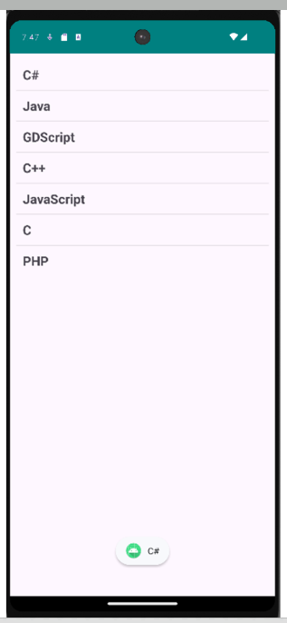

**2) Write a Program to create a Grid View and display the names of different Phones and Operating System and toast selected Phone.**

**XML Code:**

<?xml version="1.0" encoding="utf-8"?>  
<LinearLayout xmlns:android="http://schemas.android.com/apk/res/android"  
 xmlns:app="http://schemas.android.com/apk/res-auto"  
 xmlns:tools="http://schemas.android.com/tools"  
 android:layout_width="match_parent"  
 android:layout_height="match_parent"  
 android:orientation="vertical"  
 android:padding="10dp"  
 tools:context=".MainActivity">  
 <GridView  
 android:id="@+id/phone_grid"  
 android:layout_width="match_parent"  
 android:layout_height="wrap_content"  
 android:numColumns="3"  
 android:verticalSpacing="5dp"  
 android:horizontalSpacing="5dp"  
 android:layout_margin="15dp"  
 android:columnWidth="70dp"  
 android:background="#FFE742"  
 android:listSelector="#9142FF"/>  
</LinearLayout>

**Java Code:**

package com.example.madprac14;  
import androidx.appcompat.app.AppCompatActivity;  
import android.os.Bundle;  
import android.view.View;  
import android.widget.AdapterView;  
import android.widget.ArrayAdapter;  
import android.widget.GridView;  
import android.widget.ListView;  
import android.widget.TextView;  
import android.widget.Toast;  
public class MainActivity extends AppCompatActivity {  
 String[] phoneOs = { "Android", "iOS", "Windows", "macOS", "Linux", "KaiOS", "MS-DOS", "Solaris", "FreeBSD" };  
 @Override  
 protected void onCreate(Bundle savedInstanceState) {  
 super.onCreate(savedInstanceState);  
 setContentView(R.layout.activity_main);  
 GridView gridView = (GridView) findViewById(R.id.phone_grid);  
 ArrayAdapter<String> adapter = new ArrayAdapter<String>(this, android.R.layout.simple_list_item_1, phoneOs);  
 gridView.setAdapter(adapter);  
 gridView.setOnItemClickListener(new AdapterView.OnItemClickListener() {  
 @Override  
 public void onItemClick(AdapterView parent, View view, int position, long id) {  
 Toast.makeText(getApplicationContext(), ((TextView) view).getText().toString(), Toast.LENGTH_LONG).show();  
 }  
 });  
 }  
}

**Output:**

